**Smartphones-Based Web Development**

**Name: Vega Shetty**

**NEU ID : 001618586**

**The problem statement:**

As an international student arriving from India, I was often looking for answers to questions regarding Northeastern University. From the course reviews to apartment hunting, everything needed to be thoroughly researched with college seniors. The Northeastern Starter app aims to solve this conundrum.

**Features:**

Through my application, students can get the following solutions:

* Get course reviews from peers

- Students can post and view course reviews from their peers.

* Student forum to discuss topics posted by users.
* Students can post topics on the forum and reply to the same.
* View major attractions in NEU through map.
* View pinned locations of the main locations at NEU through a Map view.
* View off-campus housing at NEU.

- View tried and tested apartments near NEU.

* View media and get relevant contact information

- User can get relevant information for the University and see photos in the gallery.

**Frameworks used:**

* Back4app/ Parse - Back4App is a backend as a service platform to help developers create apps up to 4x faster. They use Parse Server framework as a core product and are the main alternative for Parse migration. In my application , I have used it to store details related to course reviews, student forum and questions asked by users.
* Mapkit - The MapKit framework provides an interface for embedding maps directly into your own windows and views. Used in my application to show map view of the campuus with pinned locations.
* UIKit – Used various features of UIKit like UICollectionViewController, UIPageViewController, UISearchController, UIWebview, etc to enhance look and feel of the application.

Screenshots:

1) Login page with segment controls and validation.

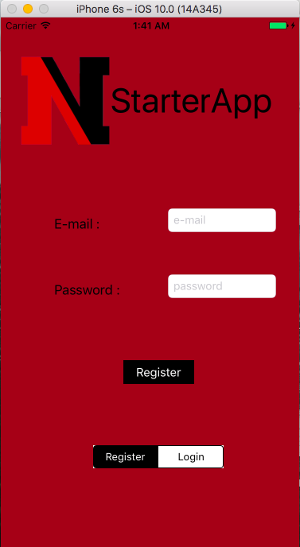

2) Side Menu for easy access to application

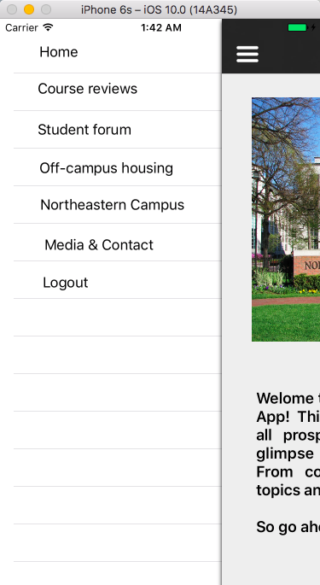

**3 ) Add and search course reviews**

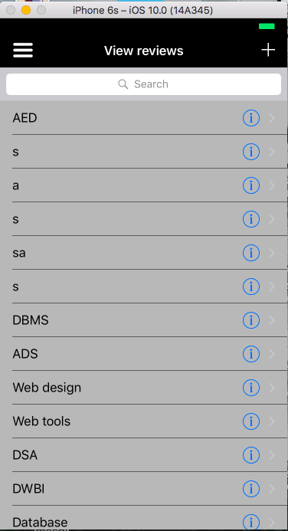 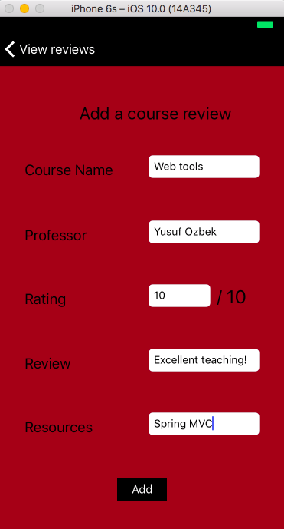

**4) Student forum to post questions and answers:**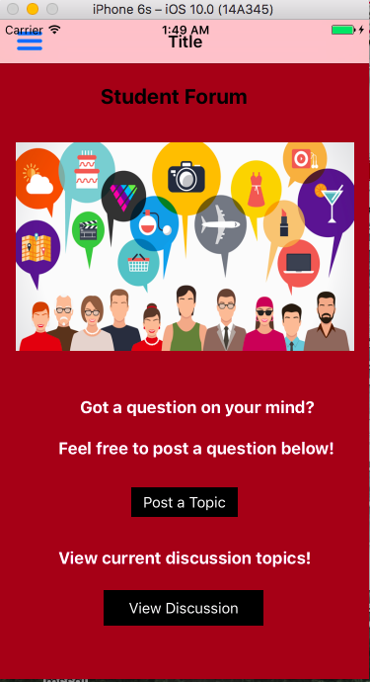 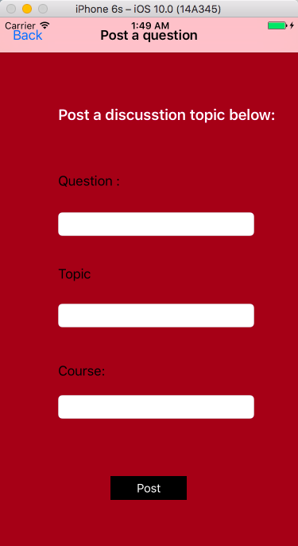

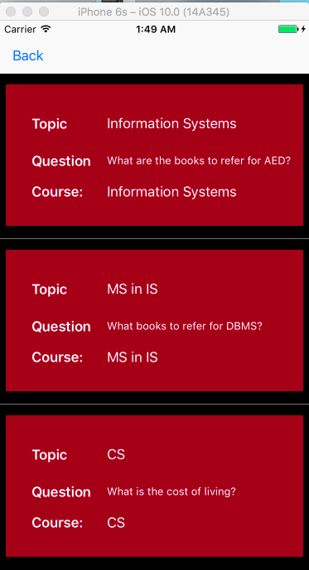 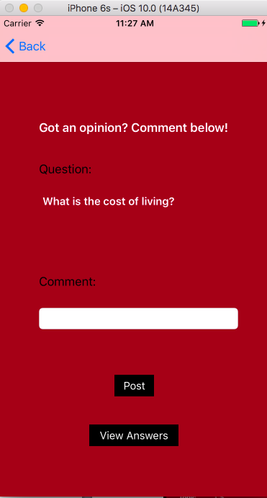

**5)**

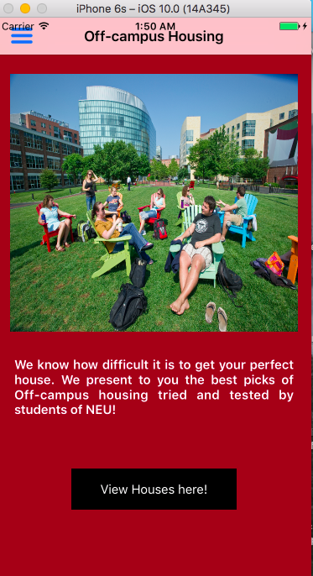 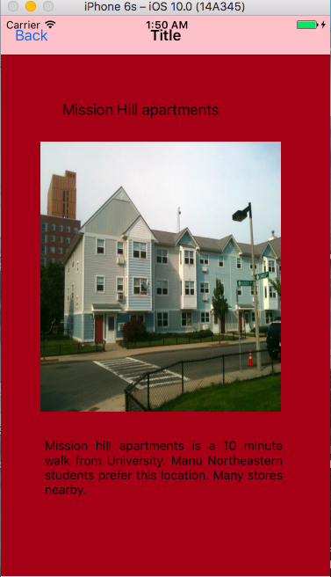

**6) Map view with pinned locations**

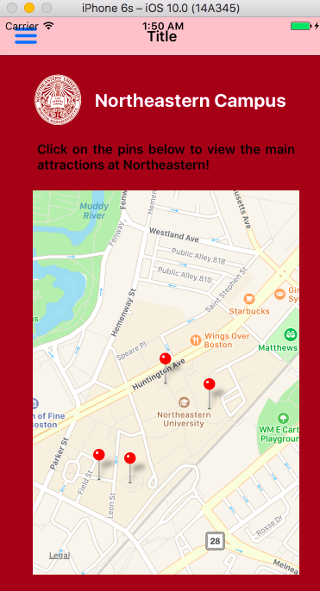

**7) Media / Contact view**

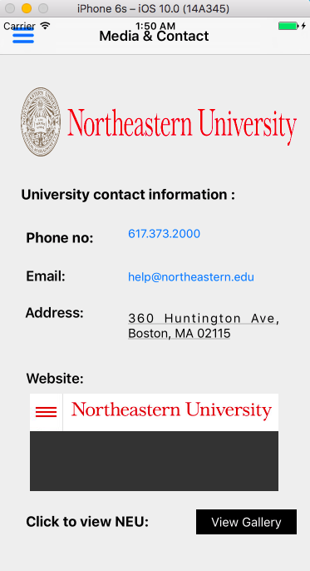 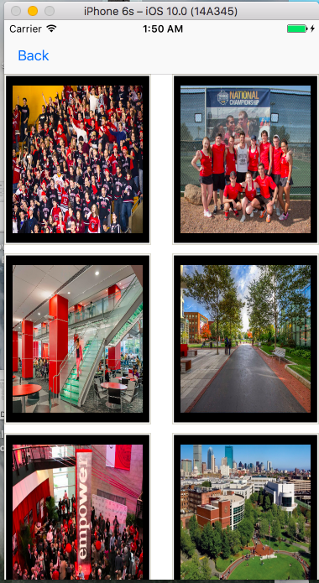

**8) Logout view :**

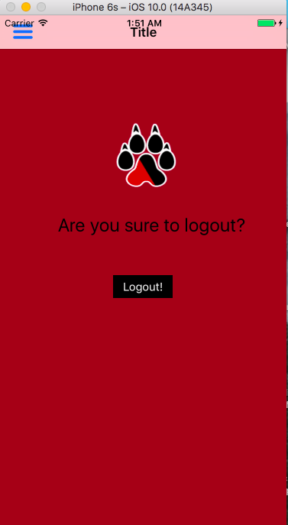

**Scope of Improvement:**

1. **Can have more user interaction between users**
2. **Use more external frameworks in addition to existing ones.**